**Week #3**

# Write a java program to add the two numbers

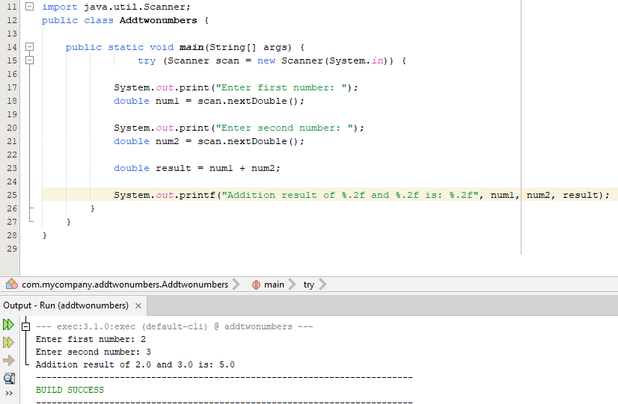

# Write a java program to multiply two floating numbers

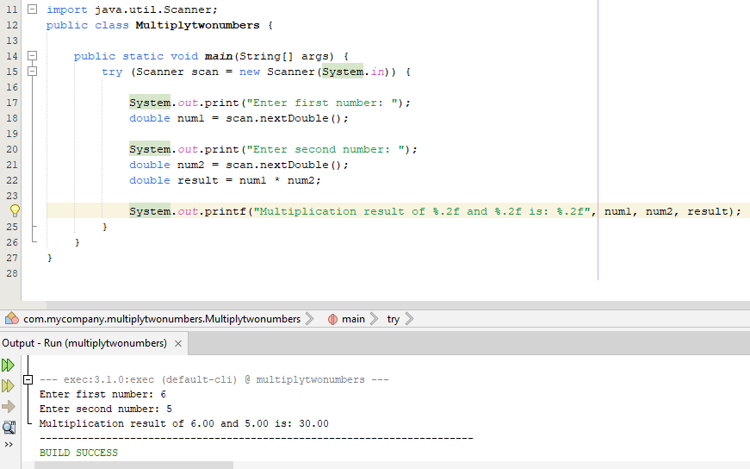

# Write a java program to display a cube of a number

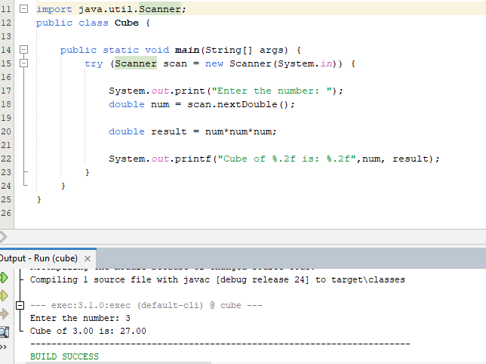

# Write a Java program that takes three numbers as input to calculate and print the average of the numbers.

# Write a Java program to compute the distance between two points

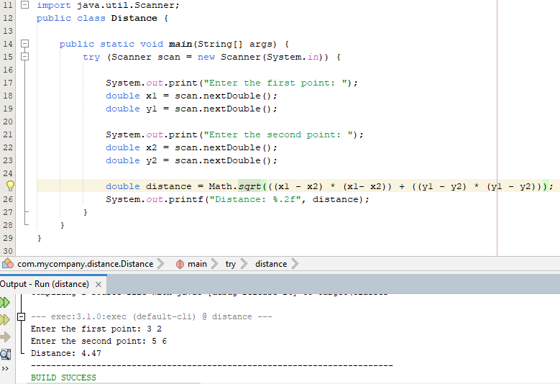

# Write a Java program to swap two numbers using a temporary variable

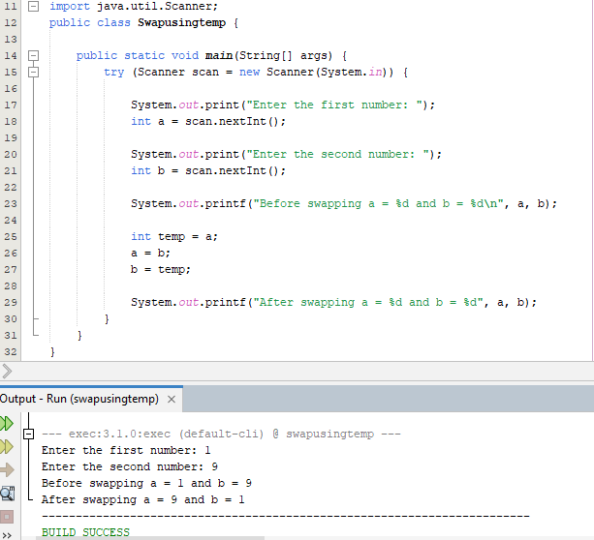

# Write a Java program to calculate the area of a rectangle given its length and breadth

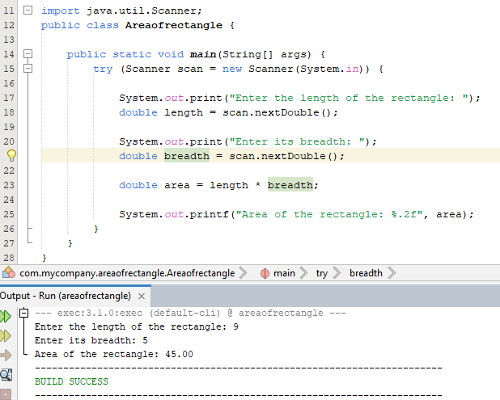

# Write a Java program to convert temperature from Celsius to Fahrenheit

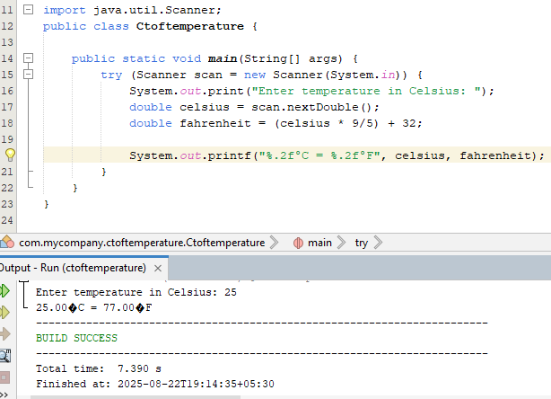

# Write a Java program that takes two integer inputs and computes their remainder and quotient

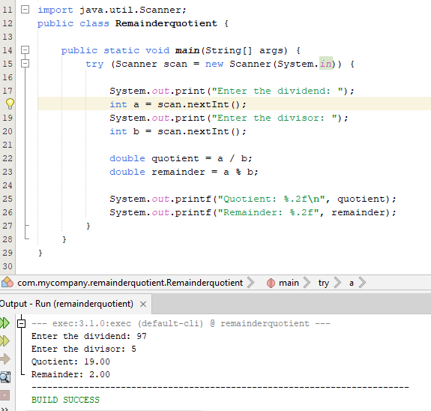

# Write a Java program to find the circumference of a circle given its radius

